

**LOVELY**

**PROFESSIONAL**

**UNIVERSITY**

**CSE-326 PROJECT REPORT**

**TOPIC: - MUSIC WEBPAGE**

**ABHINAV SYAM (12208954)**

**AUSTIN JACOB ANIL (12209074)**

**SAVIO JOSEPH FRANCIS (12209963)**

**ACKNOWLEDGEMENT**

**+-**

I would like to express my sincere thanks of gratitude to my teacher **Dr .Goutam Majumder** for his valuable guidance and support in completing my project.

I would also like to express my gratitude towards our Chancellor and Vice-chancellor, for providing me with all the facility that was required and I am also thankful to my classmates who helped a lot in completing my project.

**INTRODUCTION**

We developed a music listening website as our project. In the present system, all music websites or apps required premium memberships for enjoying music without adds and disturbance. Whereas our website “MUSSpace” provides add free music which is also add free. The project aims to provide free music enjoyment for everyone without age or class difference. Our website provides music of mostly every language and every country.

A Music Website is a website that provides music for listening

This system gives the following features to the customers:-

**Registration:** In this system, users have to register. Users have to fill in their information like their name, address, and mobile number in the registration form. After submitting the form he gets a username and password to log in to the system.

**HARDWARE REQUIREMENTS**

|  |  |
| --- | --- |
| **Processor** | Core i3 or Higher/AMD Processors. |
| **Hard Disk** | 50GB or Higher (Recommended). |
| **RAM** | 4GB or Higher (Recommended) |
| **OS** | Windows 7 or Higher (Recommended). |

**LOGIN PAGE: -**

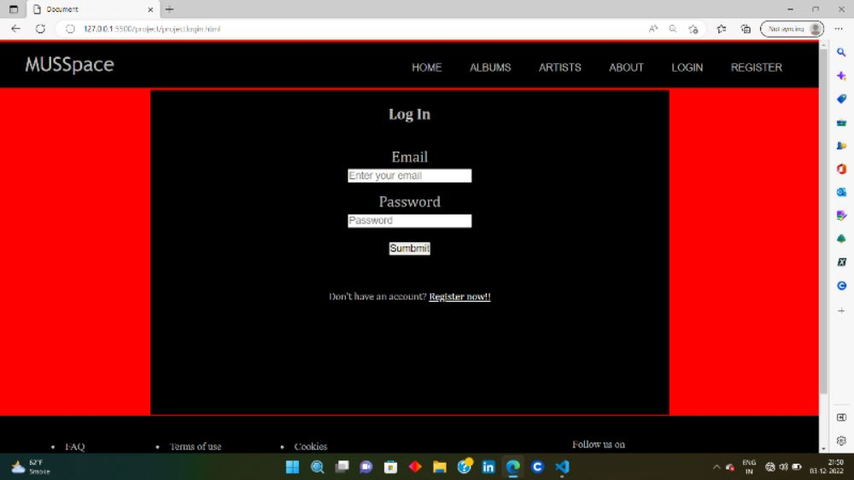

**SIGNUP PAGE:-**

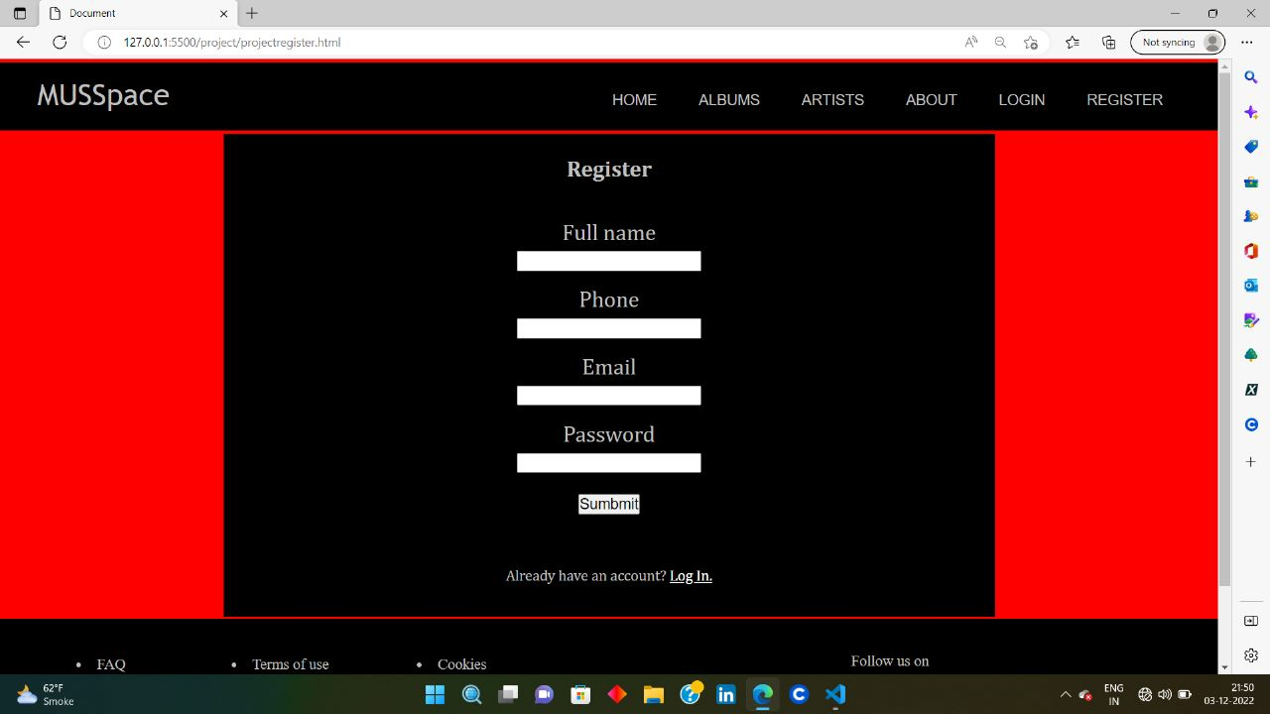

**HOME PAGE:-**

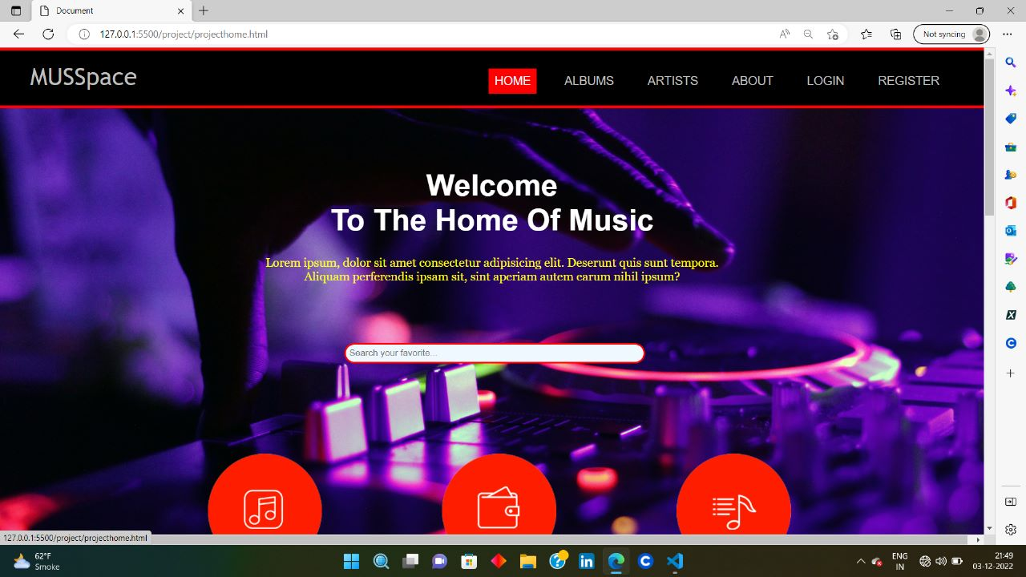

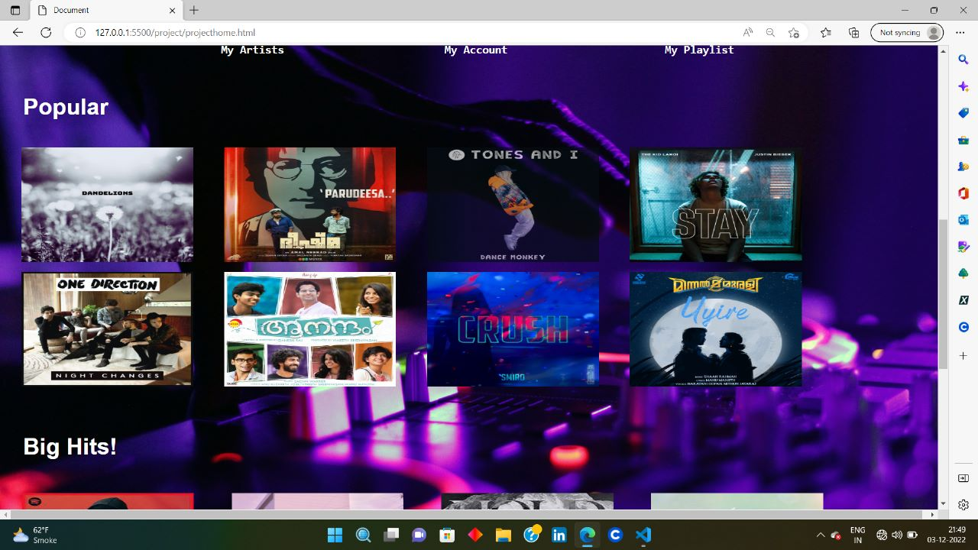

**About PAGE: -**

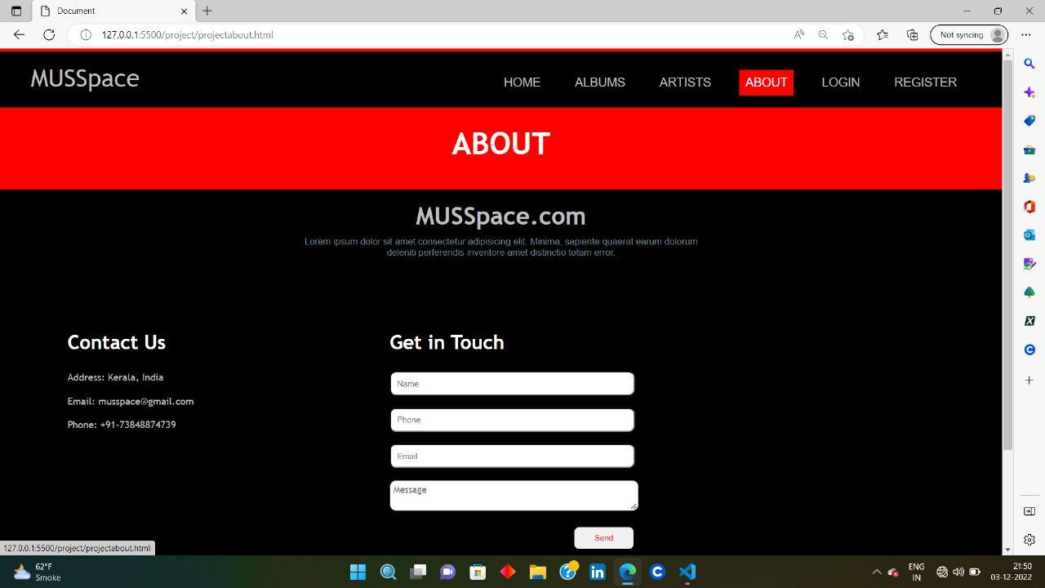

**CONCLUSION**

Music website have emerged with a new goodies compared to the past experience where every activity concerning music hearing was limited only to premium members. Nowadays, customers suffer to get free music that they have to download music or purchase premium membership in apps or website. Our website provides music in free cost in every language and of every artists.